# **Procedure CDP02-Software Engineering**

# **Choosing the Relevant technologies:**

Choosing the right technologies for a project is also a challenging activity for the software development team. This is a real need for the team to take decision for the technologies considering each and every fin detail of the project.

## **Choosing SDLC model:**

There are different software development lifecycle models for the project development, like the waterfall model, iterative model, agile model and many mothers.

It totally depends on the project behavior which model to choose.

We are using iterative model for this project development where prototype will be built in the first stage. The project is divided into three iterations, 30%, 60% and build-3 is 100%. SDLC steps are repeated after each iteration. Requirements are refined after each iteration and updates are made accordingly.

## **Choosing the programming languages:**

As there are two main modules of the project, Th Mobile Application for Employees and a Website portal for the Admin. Different Programming languages are used for both of them

## **Languages for Mobile Application:**

**Backend:** Java (Android)

**APIs for data sending to database:** Php

**Frontend:** GUI (Graphical user interface)

## **Languages for Website:**

**Backend:** Core Php, Ajax

**Frontend:** HTML, CSS, JavaScript, Bootstrap

## **Choosing Database**

**Database:** MySQL

## **Choosing IDEs**

**IDE for Application:** Android Studio

**IDE for Website:** Php Storm

# **Package Diagram of the System**

The following image shows the package diagram of the system which more clearly explains the technologies used for the project development:

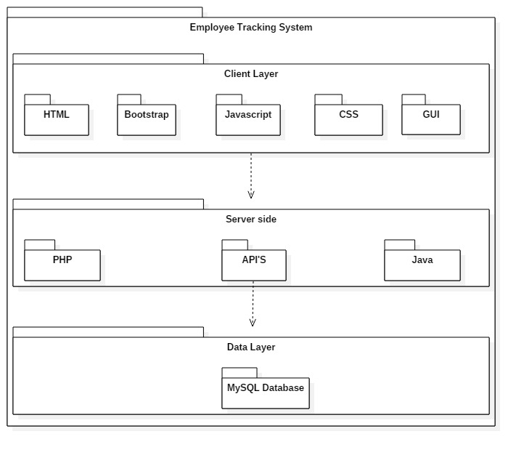

*Package Diagram*

# **Justification to the technologies:**

For website development, there are many other languages and technologies used like Flask and Django are python frameworks for web development, similarly other php frameworks like Laravel is used, but core php is one of the most easy and understandable way to develop websites, the community of core php is very vast which makes it easy for us to learn and develop. Java is also the most accepted language for android development.

# **References:**

* <https://customerthink.com/tips-to-choose-the-right-software-development-process-for-your-industry/>
* <https://asahitechnologies.com/blog/how-to-choose-the-right-software-development-methodology/>
* Self-study and research

# **Implementation Functional Requirements:**

# **Bug Fixing:**

At the time of project development, it is more than sure that the developer must be facing bugs and errors. At the time of implementation, we had a lot of bugs to solve which included minor issues too. Some of them are the following:

## **Google Map API missing:**

The google map API was missing.

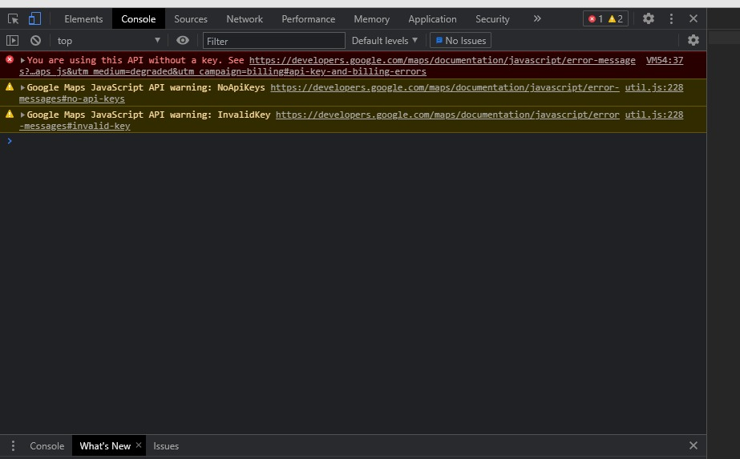

Same was here:

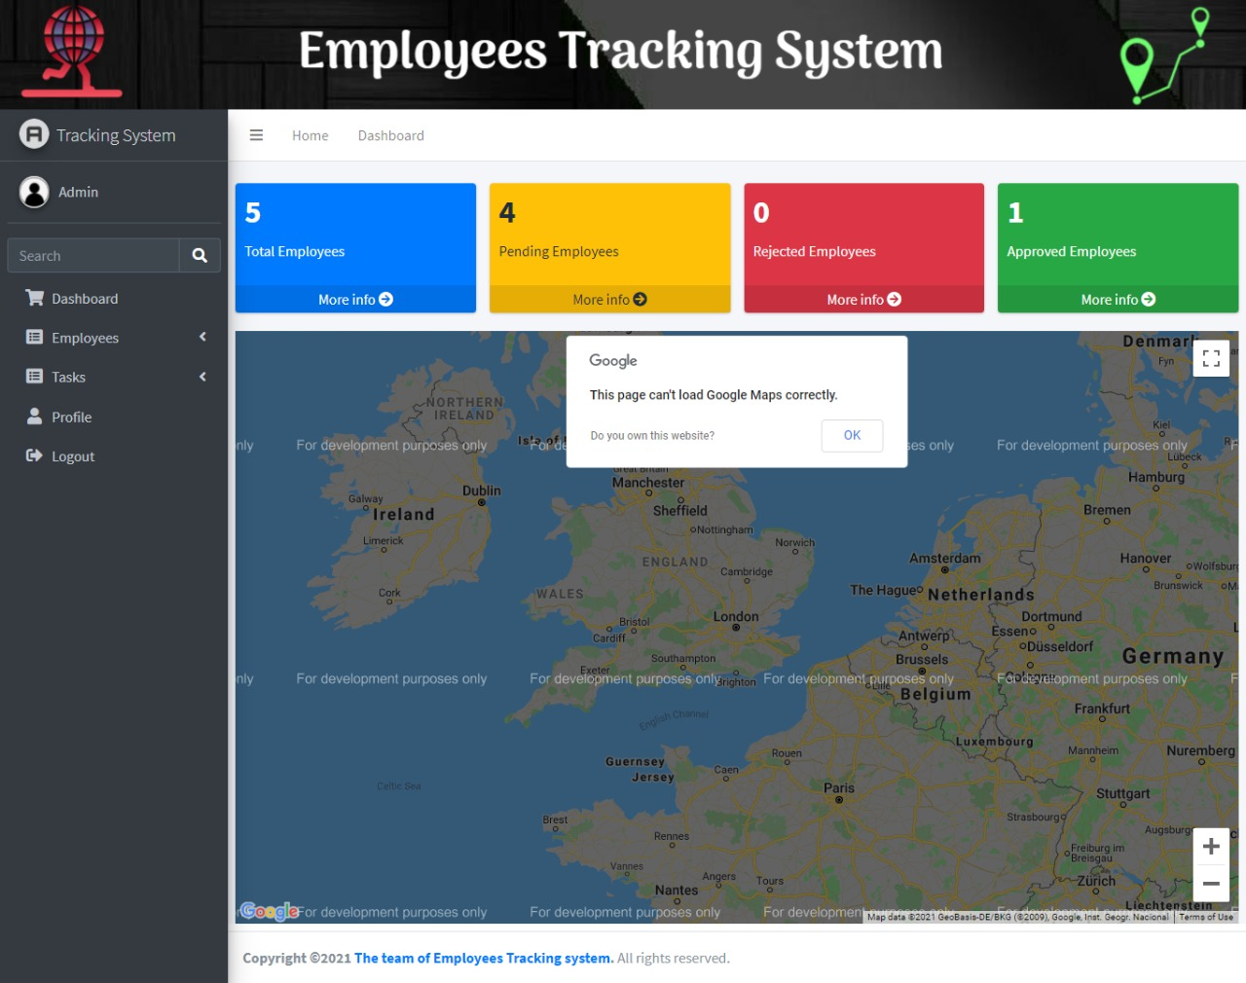

## **Solution:**

Google map API was used to fix it:

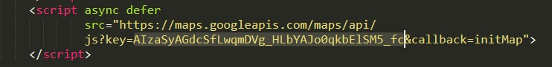

## **Array key not defined:**

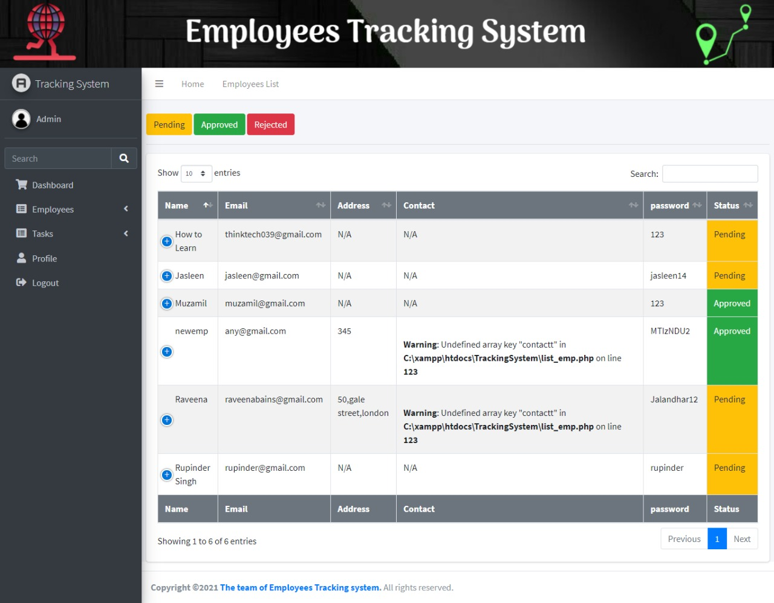

## **Solution:**

The array key was defined then.

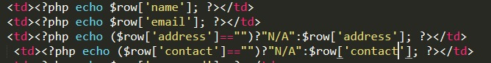

## **Undefined variable:**

Fields are empty and we tried to update the fields.

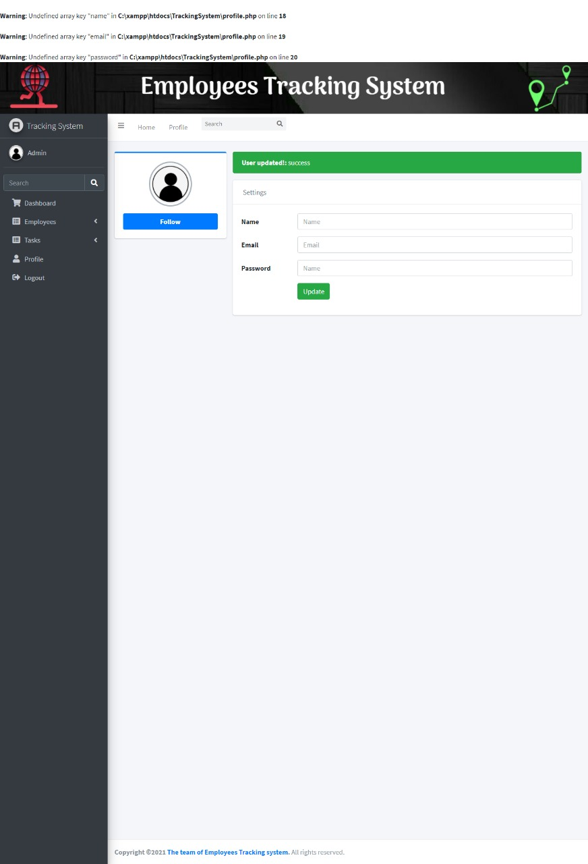

## **Solution:**

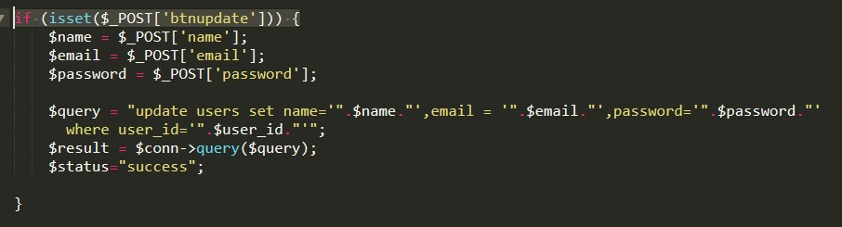

## **Card variables not defined:**

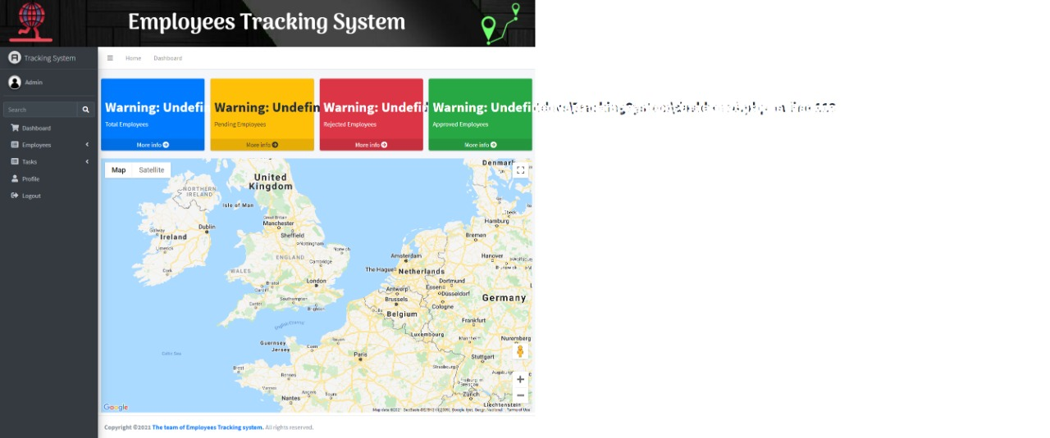

## **Solution:**

Card variables were defined properly

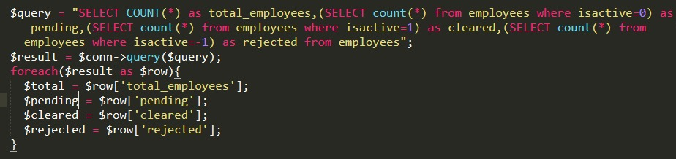

## **Problem in session variable:**

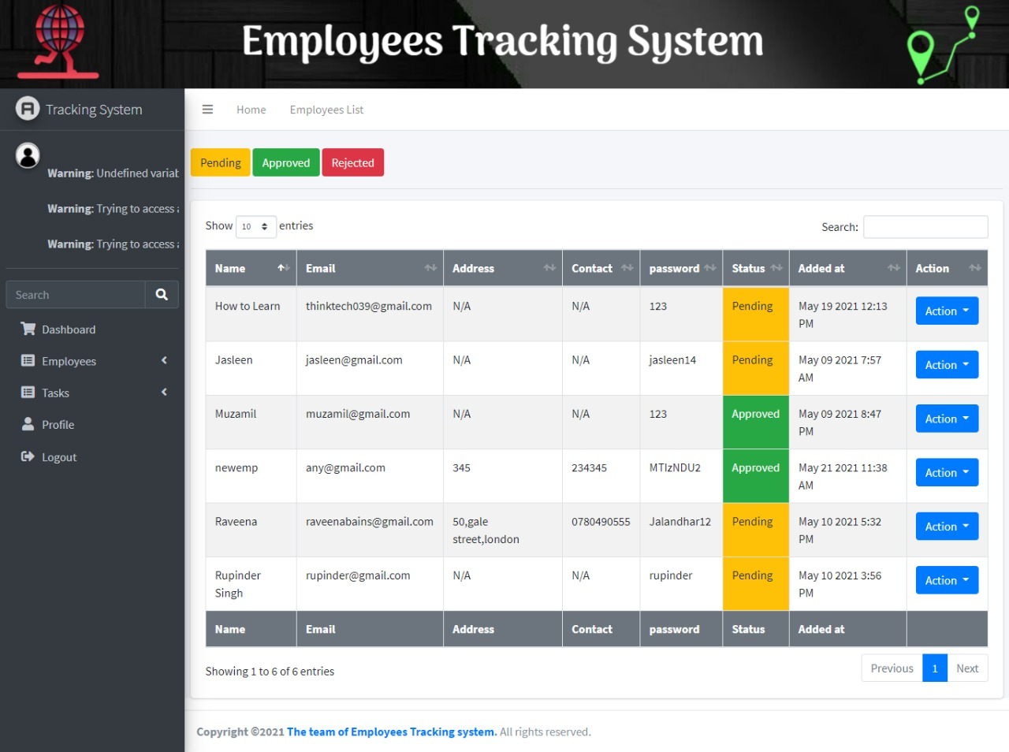

## **Solution:**

Check.php was included to include the session variables.

C:\Users\sheraz\Downloads\WhatsApp Image 2021-05-22 at 12.43.48 AM.jpeg

## **Wrong database credentials:**

Database credentials were wrong

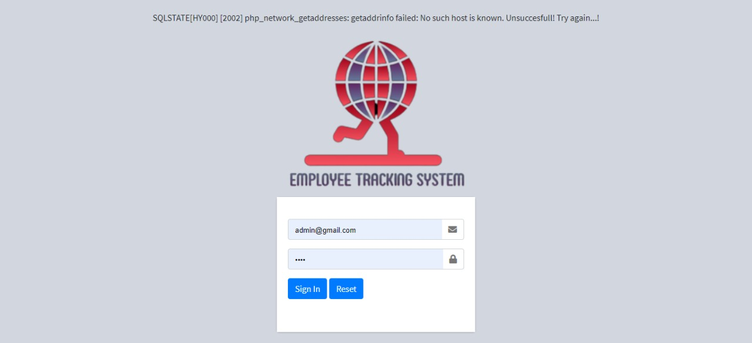

## **Solution:**

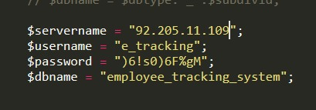

## **Undefined Variable:**

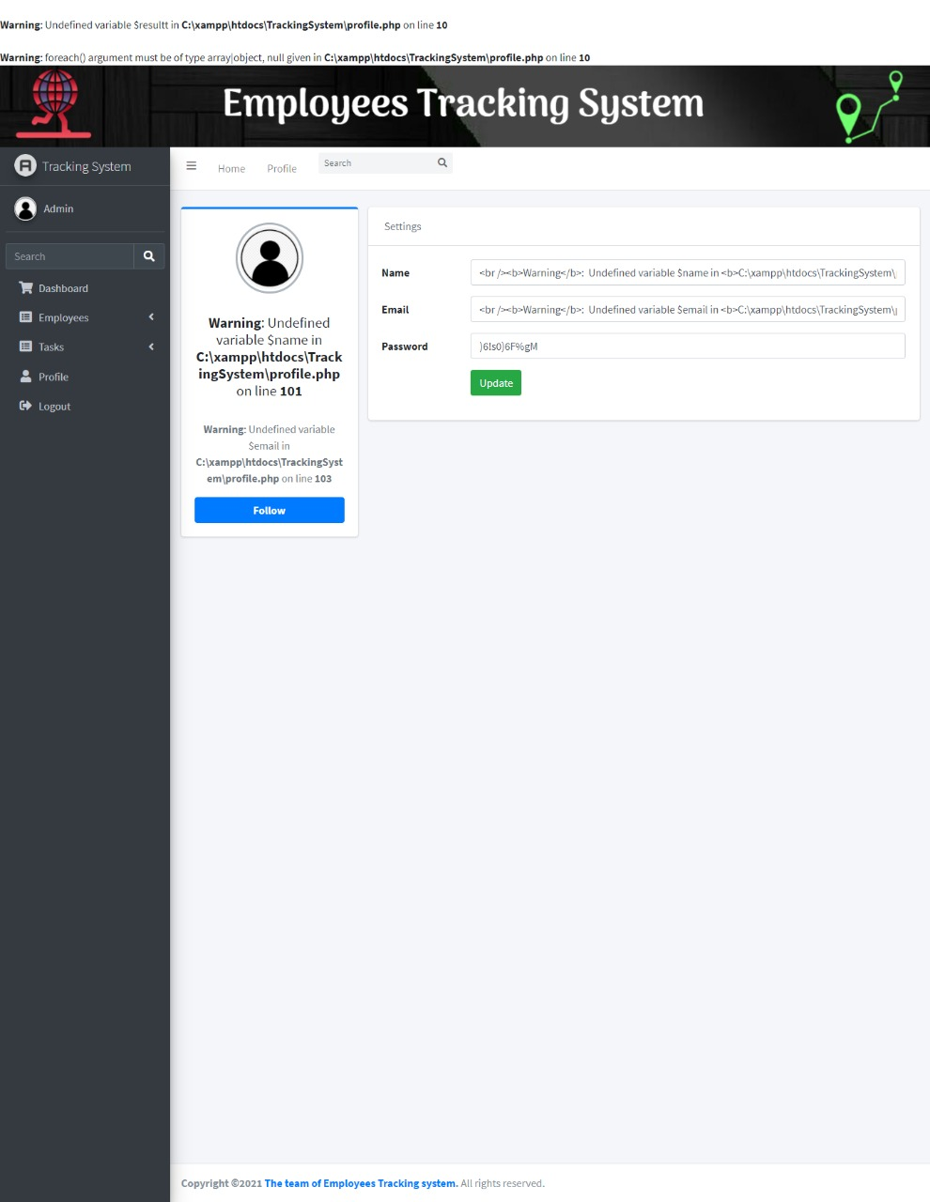

## **Solution:**

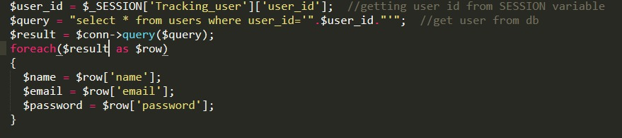

## **AsyncTask library not imported:**

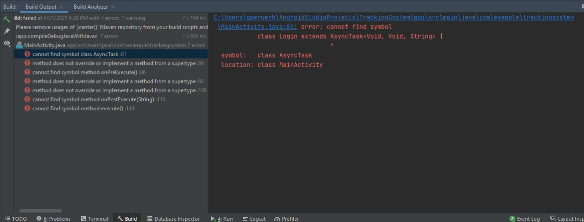

## **Solution:**

Library imported

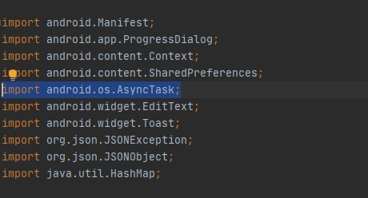

## **Geocoder not defined:**

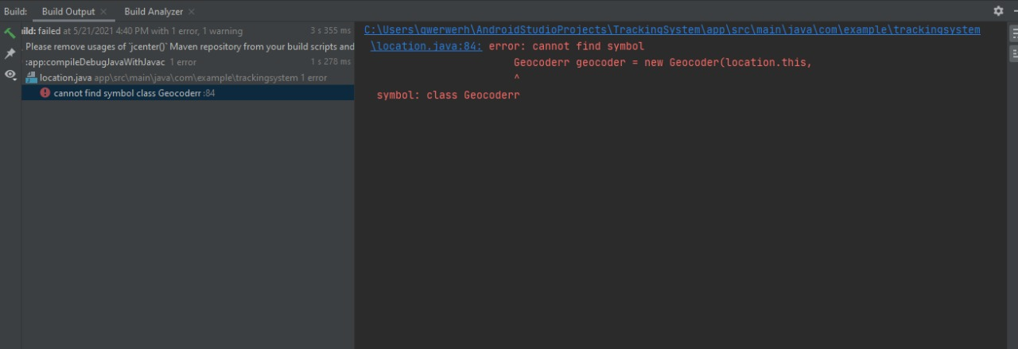

## **Solution:**

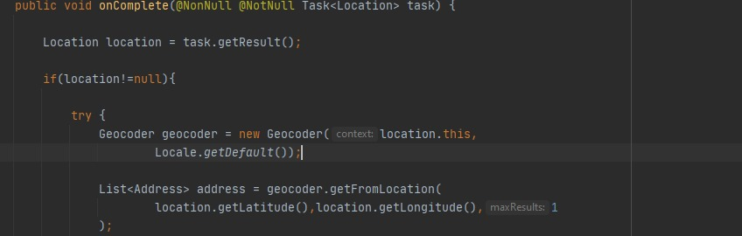

## **Request Handler Not defined:**

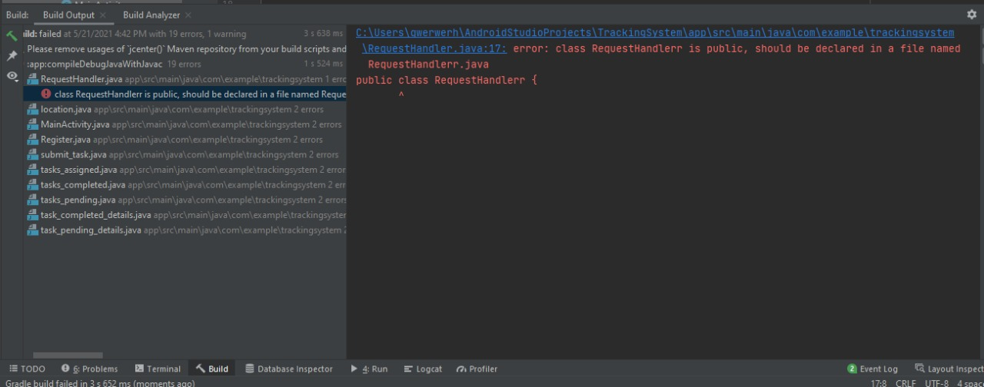

## **Solution:**

